DeMatha Catholic
High School

Handbook
For
Parents of Athletes

2022-2023

Table of Contents

Introductory Statement 3
Athletics Mission Statement 3
Athlete/Coach/Parent Relationship 3
Athletic Chain of Command 4
Selecting (Cutting) the Team 5
Expressing Concerns 5
Participation on an Athletic Team 6
NIL Policy 6
Athletic Department Conduct 8
COVID-19 Rules and Standard Operating Procedures 9
Concussion Management/ Home Care 10
Concussion Testing 11
Safety Concerns for Parents to Consider 12
Health Forms/ATS 13
DeMatha Catholic High School Philosophy 13
Electronic Device Travel Policy 13
Eligibility Requirements for Athletes 14
Fund Raising 15
Team Fees 15
Hazing 15
Locker Room Lockers 15
Participation on an Athletic Team 16
Practice Sessions and Games 16
Pre and Post Practice and Game Responsibilities 17
Team Captains 17
Purpose of Junior Varsity and Freshmen Teams 17
Athletic Letters 18
Realization of Scholarships (from the NCAA) 18
Responsibilities of an Athlete 18
Responsibilities of a Coach 19
Risk of Athletic Participation 19
Rules Regarding Unsportsmanlike Conduct 20
Sports Booster Club 20
Sportsmanship 20
Sportsmanship by Stephanie Mullen, a site devoted to parenting teens 21
Sportsmanship- Officials View 21
Sports Specialization 22
Sports Specialization Injuries 22
Substance Abuse 23
Team Travel 23
Transition Game (By Gary Stevens CMAA) 24
WCAC Sportsmanship Creed 24
Web Page 25
Weight Room Fee 25
DeMatha Student-Athlete Checklist of forms 26
Signature and Sign-Off Sheet 27
Appendixes 28
Appendix A- Permission Form and Release
Appendix B- DeMatha Transportation Verification Carpool
Appendix C- DeMatha Transportation Verification Return Trip with Parents
Appendix D- DeMatha Waiver of Liability and Hold Harmless Agreement for OSAs
Appendix E- Washington Catholic Athletic Conference Transfer Policy (5-1-2020)

Handbook for Parents of Athletes

Introductory Statement

In the gospel, Jesus tells us that each person has a variety of talents (Matthew 25:14-30). Athletic talent is only one of the many gifts God has given us. It is Jesus’ constant teaching that each human being is required, not encouraged, but required to develop the talent given to him by God, and in this way reach his full potential as a human being and a believing Christian.

Athletics Mission Statement

The interscholastic athletic program is a significant element in the overall mission of DeMatha Catholic High School. It reflects the concept of the mind/body relationship. Like all programs at DeMatha, participation is designed to promote the growth of our students through exposure to worthy role models, good sportsmanship and team loyalty. While winning will always be an important goal of any team, winning the “right way” will be the single outcome by which success will be measured.

Athlete/Coach/Parent Relationships

There is and perhaps always will be an inherent tension in the triangulated relationship of coach/player/parent. The coach’s interests are all about what is best for the team. This is often at odds with the concerns of a parent who typically wants what is best for his or her son. Then there is the player who is torn between what the coach is attempting to achieve with the team and his loyalty and love for his parents. This is a terrible place to put a young high school student. Athletics should be fun and enjoyable. His athletic experience could be a disaster if you:
- Continue to tell him that the coach is deficient.
- Tell your son that the “coach is not seeing the real you” as the leader, player, or person.
- Tell your son that the coach is using him in the wrong position or at the wrong time.
- Take it upon yourself to change the skills being taught or hire a personal trainer to work with your son without the knowledge and cooperation of the coach.
- Tell your son “Coach doesn’t like you”.
- Live off past experiences. He is now in a high school setting, he must perform.

It is obvious in the last ten to fifteen years this potential conflict of interests has intensified. There are several reasons for this. First, the competition in the league has never been at a higher pitch than it is today. Secondly, the media has decided that high school sports are now very marketable and is willing to devote more resources in covering them. Then there is the customary practice of parents attempting to live their lives vicariously through their children. Finally, parents of today’s high school athletes know how expensive college has become and are hoping for athletic scholarships. All of these factors have the potential to contribute to the tension stated above.

The ideal that we seek is for coaches and parents to act like mature adults and realize all the goals that they have in common. They should both want the young men to grow in a positive direction and benefit from athletic participation. Remember, there is only one ball. Everyone will not play. You may have to sit on the bench and wait your turn. There are few things that are healthier for young men than sports. They learn to compete in a society based on competition. They need to work and train to make themselves stand out among the competition. If what they did yesterday still looks good today, they haven’t done much today. Athletes learn how to interact with others who are trying to achieve the same team oriented goals, much like they will in the business world. They remain physically fit, no small outcome in a world tainted by obesity. John Wooden, the great basketball coach of UCLA in its glory years, had a most appropriate response to reporters when asked how he would gauge the success of his team in a particular year. He responded that success could only be measured by looking at where the players were five to ten years later and seeing what kind of young men they had become. It is the long-range outcome that should receive the most emphasis.

If a parent/athlete has a concern about his son’s place on a team, he should contact the coach (NOT after a game) and make an appointment to see him. E-mail is the least effective way to voice a difference of opinion. Seeing the coach in person or phoning are the preferred communication methods. There is nothing wrong with disagreeing as long as you are not disagreeable. Remember, the coach’s perspective is team oriented and the parent’s perspective will be an individual one. Most times, these will not fully complement each other.

Most high school athletes have parents who themselves were athletes once upon a time. It would be naïve to think that the parents will not “coach” their sons to some degree. However, this parental coaching can never be at odds with the coaching priorities of the team’s coach. If this were to happen, the outcomes for the young men can never be beneficial. If the player disregards the direction of the parent, then he compromises his familial relationship. If he attempts to carry out this direction, then his place on the team and his relationship with the coach will be compromised. Do not put him in this precarious position.

One last thing should be kept in mind. High school coaches are hired not only to coach your sons but also to act as educators. They are not paid much, particularly given the great amount of time they devote to their coaching. The ideal coach loves his sport and loves working with high school student athletes. He is one of your son’s most important teachers and the coach/athlete relationship is often a much closer one than that of a classroom teacher. Work with the coach and encourage your son to grow from his athletic experience. In five to ten years everyone can then realize how successful the participation was.

Athletic Chain of Command
At DeMatha Catholic High School, the following chain of command is in effect:

Players/Captain
Assistant Coach
Head Coach
Athletic Director

If there are any questions or concerns involving some aspect of our athletic program, the athlete should first contact the appropriate person. If there is no resolution, he would follow the chain of command.
Selecting (Cutting) the Team
While our ultimate goal is to promote the greatest athletic participation possible at DeMatha Catholic High School, in some sports it is necessary to select a squad. This may occur due to limitations of our facilities, equipment, regulations specific to some sports, travel restrictions, and other factors. Sometimes players are cut only to come back the next year and contribute to the team. On the other hand, just because you did everything that was requested of the coach, it doesn’t guarantee that you will make the team. The most famous example has been Michael Jordan. Our own example is Markelle Fultz (‘16). He was cut from the varsity team to play JV basketball. The following year he came back to make the Varsity, earned a scholarship to the University of Washington, and later became the #1 pick in the NBA draft.
Every coach has the responsibility and authority for selecting his or her team. The criteria for selecting the team are developed by the head coach with the help of his staff.
It is also important to remember that there are no guarantees. Players from the previous year's JV team, for example, do not automatically make either the JV or varsity squad the following year. Having been a member of a team during the previous year or even being a senior does not ensure that an athlete will make the squad.
Parents should expect that every candidate is treated fairly and given every consideration. Coaches are sensitive to feelings of disappointment, will handle the task as positively as possible, and will be available to answer athletes' questions.
While we understand that being cut is disappointing for many athletes and even for their parents, we unfortunately cannot keep everyone on the team. It is not the end of the world. Anyone cut from a team is welcome to try out again next season or to try another sport or activity. There are numerous clubs and organizations at DeMatha in which one can participate. Athletes can excel in different sports other than the ones they would like to play. There was an athlete a few years ago that thought he was a basketball player but was cut and tried another sport. He now sports an Olympic Gold Medal in track. When parents and athletes understand and support the coach's decision, this difficult process becomes a less painful experience for all.

Expressing Concerns
When expressing an occasional concern with a coach, please refer to and use the following guidelines:
- Never approach a coach immediately after a contest. This is not the proper time or place for a discussion concerning your son or the team.
- Call the coach the following day and make an appointment, choose a time which is convenient for both you and the coach to meet.
- Raise your concerns in a calm and civil manner. Have them written down so nothing is forgotten or left out. Yelling, being rude or using foul language is totally unacceptable and will not be tolerated.
- Once you have stated your question or concern, listen to the explanation. Often a parent may be blinded by emotion and this overrides logic and reason. Listening receptively may really help you to understand any explanation, which is given.
- Always keep in mind that sports teams are exactly that, “a team”. Decisions will be made in light of the team concept and school. They may not be the best for you or your son but in the best interest of the team or school.
- Issues NOT appropriate to discuss with the coaches are: playing time, team strategy, play calling, and other athletes.
- Appropriate concerns to discuss include the treatment of your child, ways to improve his performance, and safety issues.
- Please understand the answer you are looking for may not be an option. We are dealing with team sports and business will be conducted as so.
- The best player doesn’t always play. The best team plays.

Participation on an Athletic Team
It is important to understand that participation on an athletic team at DeMatha Catholic High School is a privilege and not a right. Maintaining one's membership on the team means accepting all the responsibilities of an athlete. However, unlike recreational teams, CYO, or intramural teams, equal or guaranteed playing time does not exist. Being a member of a team one year, does not guarantee being a member of the team the following season. In an effort to win on the varsity level a coach will use players best suited to the conditions or demands of the contest at that time. Although everybody wants to win, the sub-varsity levels will stress fundamentals and teamwork. The league only recognizes champions on the varsity level. As much as we would like to play seniors on senior day, there are no guarantees. They will be recognized before or at half time of the game, but it may be that we are in the hunt for a championship or a seeding and the best team will be fielded.

NIL Policy

This policy sets forth the provisions that apply if a DeMatha student-athlete or prospective
student-athlete (collectively sometimes referred to as “Student-Athlete”) chooses to receive compensation for use of their NIL. Because of the changing regulatory landscape, DeMatha may need to amend, replace or rescind this Policy if, for example, federal, state, conference or other authorities adopt new or amended policies, requirements or laws. DeMatha’s Department of Athletics may publish additional materials to further clarify or implement this Policy.

NIL Defined

NIL activity is any activity in which a Student-Athlete’s name, image or likeness is used for promotional or commercial purposes. Such use may be compensated (e.g., cash, product or other benefit).

Guidelines

The following provisions apply to DeMatha Student-Athletes who choose to use their NIL to earn compensation:

- Student-Athletes must comply with all applicable state and federal laws and regulations as well as all applicable policies or requirements of the WCAC, other applicable athletics association or governing body and DeMatha.

- NIL compensation may not be related to pay-for-play, impermissible offers and inducement or extra benefits, including but not limited to:

- NIL agreements provided without quid pro quo (e.g., cannot be payments for work not performed);
- NIL payments provided or offered contingent on initial or continued enrollment at DeMatha;
- NIL payments contingent on specific athletic performance or achievement (e.g., financial incentives based on points scored). Athletic performance may enhance a Student-Athlete’s NIL value but may not be “consideration” for NIL compensation.

- A Student-Athlete may not engage in any NIL activity in a manner that conflicts with a term of any DeMatha contract (for example, engaging in NIL activities for a competitor of any existing DeMatha sponsorship arrangement) or DeMatha’s Student Handbook.

- A Student-Athlete may not use their NIL to promote casinos or gambling, including sports betting and the lottery; alcohol products; tobacco, nicotine and electronic smoking products and devices; cannabis, cannabinoids, cannabidoil or other derivatives; drug paraphernalia; controlled dangerous substances; prescription pharmaceuticals; adult entertainment, services and products; video games, on-line games and mobile devices; weapons, including firearms and ammunition; substances banned by the NCAA; or products or services that are illegal or that are contrary to the religious or academic mission of DeMatha.

- A Student-Athlete may not engage in any NIL activities on DeMatha property or during any school, athletics department, or school or team related activity (e.g., practice, competition, team meals or any other activity organized by the athletics department or team).

- A Student-Athlete may not use or make reference to the name, symbols logos, trademarks, facilities and/or images associated with DeMathat or the WCAC, including not appearing in any athletic uniforms or gear (both game and practice) or academic school uniforms of DeMatha.
- A Student-Athlete must disclose all NIL activities to DeMatha in the manner set forth by the Department of Athletics.

Disclaimer

DeMatha is not providing and cannot provide legal advice to a Student-Athlete or his family. Compliance with this Policy does not ensure eligibility under the standards of other institutions or athletics organizations, including, but not limited to the NCAA or other collegiate athletics associations.

DeMatha is not permitted to assist Student-Athletes with identifying, selecting, arranging or providing payment for professional service providers. DeMatha is not liable or otherwise responsible to any Student-Athlete, entity that partners with a Student-Athlete, professional service provider or other person or entity included with NIL activities or NIL related agreements with any Student-Athlete.

Changes to Policy

DeMatha, in its sole and absolute discretion, may amend or rescind this Policy at any time.

Athletic Department Conduct
While under the supervision of the coaching staff at DeMatha Catholic High School, and while engaging in any activity connected with a DeMatha team, an athlete must at all times place the best interests of his team and his school above his own personal interests. This includes all practice sessions, contests, traveling to and from such events and in any other situation where the purpose of the activity is related to team membership.
In cases where the conduct of an athlete becomes inappropriate as a representative of our school's interscholastic program, he may be subject to expulsion from the team. Such measures will be taken only after consideration of the circumstances by the coach.
The following is a list of violations, which our coaching staff considers to be unacceptable behavior and which would, in all probability, result in the forfeiture of team membership. This list should not be considered complete, since there could be other infractions occurring of the same severity.
- Use of drugs
- Use of tobacco products
- Vaping
- Use of alcohol
- Stealing
- Flagrant misconduct
- Insubordination
- Poor Sportsmanship
- Hazing
- Vandalism
- Failure to meet responsibilities to the team: Family vacations (other than during the times designated by the school calendar), routine dental checkups, hair appointments, baby-sitting, etc. are examples of unacceptable substitutes for team practice sessions and games

COVID-19 Rules and Standard Operating Procedures (see DeMatha website under About)

DeMatha COVID Policy
COVID Vaccine/Exposure Information
Are you “up to date”?
Moderna/Pfizer 🡪 received the 2 primary shots, as well as a booster
Johnson & Johnson 🡪 1 primary shot, as well as a booster
What is an “exposure”?
If you have been within 6ft of someone who tested positive for COVID-19 without wearing a mask for longer than 15min
DeMatha Exposure Guidelines

Vax Status | Quarantine? | Testing? | Mask use? | Return to sports?
Up to Date | No, unless you develop symptoms | 5 days post exposure | Continue to wear well fitting mask when in public/around people | Do not need to stop activities unless symptoms develop
Unvaccinated/Not Up to Date | 5 days, wear mask around anyone in your household | 5 days post exposure | Continue to wear well fitting mask when in public/around people | Do not need to stop activities unless symptoms develop

What to do at Home
Someone in my household tested positive, what do I do?
- That individual should be isolated within the home for 5 days, limiting contact with anyone else as much as possible
- Refer to exposure guidelines for any remaining people within the household
Someone in my household was exposed to someone who tested positive, what do I do?
- That person should refer to the exposure guidelines and act according to their vaccine status
- Anyone else in the household should maintain safe practices when around the individual that was exposed based on your own vaccination status
DeMatha Policy for Students Who Test Positive

- All individuals who receive a positive test, regardless of vaccination status, must complete a full, 5 day isolation.
  - Day 0 = day of positive test
Days 1-5 = isolation
Day 6 = may return to school
  - In the event that symptoms persist past the 5 day isolation, that individual may not return to school until their symptoms have resolved for 24hrs.
  - A negative test is not required to return to school after completion of the isolation period.
- All individuals who receive a positive test, regardless of whether or not they were symptomatic, must wear a mask AT ALL TIMES for a full, 10 day period.
  - This means that any athletes, musicians (instrumental or vocal), etc. may not return to their activities for 10 days following their positive test.
- For 30 days following a positive test and completion of the isolation period, any subsequent positive tests will not require another isolation period.
Where to Report Positive Tests

If a student tests positive for COVID outside of any on campus testing, their case must be reported to the Athletic Training Room. Please call (240)-764-2253 and speak with one of the athletic trainers, or email Wendy Norris at wnorris@dematha.org.

CONCUSSION MANAGEMENT

A concussion is a type of traumatic brain injury, or TBI, caused by a bump, blow, or jolt to the head or by a hit to the body that causes the head and brain to move quickly back and forth. Signs and symptoms can appear immediately or not be noticed until days or even weeks after the injury.

SIGNS AND SYMPTOMS:
Dazed, stunned, confused, lack concentration | Balance Problems/dizziness
Bothered by light or noise | Sleep Problems
Memory (can’t recall events) | Pressure in head/worsening headaches
Behavior changes, irritability | Nausea

SIGNS TO CALL ER/DOCTOR:
One pupil larger than other | Loss consciousness/can’t wake up
Vomiting | Can’t recognize people or places
Weakness/Numbness in arms or legs | Seizures
Loss of consciousness | Slurred speech

HOME CARE:

Report symptoms: If your child has sustained a concussion you must notify the athletic trainer. All of your son's coaches should be notified as well.
Get checked: Only a health care provider who has been trained in concussion management may clear an athlete to return to play.
Get rest: Keep a regular sleep routine and reduce activities that require a lot of excess concentration (i.e.: homework, computer/tv, etc.). When completing school assignments take breaks to reduce strain.
Medication: Do NOT give a child with a suspected head injury any Aspirin or Ibuprofen products, Tylenol/Acetaminophen only.
Address concerns: Never hesitate to contact DeMatha's athletic trainers or another health care professional if you have any questions or concerns!
Take it slow: Returning a child too early without allowing them time to completely heal can lead to a longer recovery time and increases the likelihood of long-term problems. The athletic trainers will work with your child to develop a safe and progressive plan to return to play.

****In severe cases, another hit to the head can lead to severe brain swelling known as Second Impact Syndrome, which can have devastating and even fatal consequences.

CONCUSSION TESTING

DeMatha utilizes XLNTbrain, an online computer program that offers complete concussion management. Concussions are a complex brain injury that are not typically visible on routine scans of the brain, yet are detectable when important aspects of brain function are tested and measured. This software uses specific testing strategies to recognize whether or not someone's brain is functioning at its normal capacity.

XLNTbrain is the most efficient way for all members of the DeMatha community, including athletes, guardians, athletic trainers, coaches, and counselors/faculty, to recognize, report, and help our students recover from concussions. Every student and guardian creates their own account online, where both must watch an educational video and pass a brief quiz about the signs and symptoms of concussions. Upon entering DeMatha, all students (as a freshman or a transfer) will take a baseline test to establish their individual norms. This way if they sustain a concussion, they can take the test again and their results will be compared to their baseline to evaluate their brain function. The baseline test can be self-administered using a computer at home, and is set up in a "video-game" style that takes roughly 30 minutes to complete. It tracks information such as memory, reaction time, processing speed, and concentration.

Each student will receive a unique identification code that can be used to link their profiles to their guardians', making their results and recovery status available to them in addition to the athletic trainers. If a student with a concussion fails the XLNTbrain test a report is generated that provides recommended accommodations to help them while in school, such as extended time for assignments, scheduled sensory breaks, etc. that are specific to that individual. An athlete with a concussion will be required to complete daily symptom check-ins as well, to monitor any changes in how they're feeling. Their profiles will also include a color coded status bar that will allow all parties (athletic trainers, guardians, coaches, and counselors) to see where their son/student/athlete is in the recovery process.

Signing the handbook sheets acknowledges that you have been informed about what a concussion is and how to recognize one, and gives us permission to use the XLNTbrain tests.

Safety Concerns for Parents to Consider
Your son's safety is our number one priority at DeMatha Catholic High School. We have compiled some valuable resources to help YOU keep your son in the game. Please refer to the links below for important information on:
- Concussions
  - Fact Sheet For Parents
  - Concussion Info
  - Return To Play Progression
- Nutrition
  - Nutrition For Sports Performance
  - Healthy Ways To Manage Weight
  - Nutrition For Immobilization And Surgery
- Sickle Cell Information Sheet
- Preventing Heat-Related Illnesses
- Sudden Deaths In Athletes
- Recognizing Asthma
- Athlete Burnout And Mental Health
- Avoiding Baseball-Related Injuries
- Suicide Prevention
These articles are referenced from the National Athletic Trainers Association, the Center for Disease Control and the Gatorade Sports Science Institute. Please refer any questions to the athletic training staff.
Once you have reviewed the above information, please sign the form included in the health forms packet and upload to ATS.

Health Forms/ATS

All students enrolled at DeMatha are required to submit five medical health forms via the ATS portal:
- Physical
- Emergency form
- Medical history form
- Safe Sports Acknowledgement form
- Immunization record

If a student wishes to join an athletic team they must submit the weight room waiver and permission/release forms found in this handbook in addition to the initial required five.

Physicals must be dated after June 1st of the upcoming school year and turned in prior to the first day of class or tryouts for fall athletes. Students will NOT be allowed to attend school or participate in their sport if paperwork is not complete.

DeMatha does not provide medical insurance for athletic injuries. All paperwork must be completed and resubmitted for each subsequent year of attendance at DeMatha, with the exception of the immunization record which only needs to be submitted once. Once all forms have been completed, the student, parent or guardian must scan and upload them to the student's ATS profile.

All medical forms as well as instructions for creating an ATS account can be found on the DeMatha website, www.dematha.org, under the "ATS/Forms/Physicals" link in the Athletics section. If you have difficulty or concerns with the ATS site, please contact Wendy Norris at wnorris@dematha.org, Jennifer Reading at jreading@dematha.org, Ava Griese at agriese@dematha.org or Hailey Rust at hrust@dematha.org.

DeMatha Catholic High School Philosophy

In addition to embracing and committing to this philosophy, DeMatha Catholic High School, will also encourage and promote:

- The belief that athletes should participate in multiple sports and not specialize in any one specific sport.
- The concept of the broadest-based participation made possible by offering a variety of teams, extending the opportunity for participation to as many students as possible and to maintain a safe environment.
- The premise that all teams are considered vital for our student-athletes and each is a valued part of our athletic program. No one sport is more important than any other.
- The approach that all teams are treated fairly.

Electronic Devices Travel Policy

All DeMatha students are responsible for the proper use of their electronic devices at all times with regards to any DeMatha sponsored travel event or function. Any violations or infractions as a result of the misuse of any electronic device may result in administrative issued penalties that may include the termination of a student from the DeMatha Catholic High School. All moderators, coaches, chaperones, faculty, and staff that attend the DeMatha sponsored travel event or function may, at their discretion, collect all electronic devices. If a student refuses to cooperate with the trip moderators request the student may face additional penalties from the DeMatha High School administration which may lead to their termination from DeMatha Catholic High School.

Eligibility Requirements for Athletes

All athletes must meet and maintain the academic standards set up by DeMatha. Academic commitments take precedence over athletic events and participation in athletics is not an acceptable excuse for poor academic performance. If an athlete falls below those standards, they will be placed on Academic Probation meaning:

- The Coach will also inform the player of Academic Probation and when it will be implemented.
- Players cannot dress for games.
- Players cannot be on the sidelines/bench.
- Players cannot ride the bus to games.
- Players can continue to practice.
- Players can use school transportation to practice.
- The Athlete cannot participate in games until his grades are improved and cleared by the Dean of Academics or the Principal.

Academic Probation is determined at the end of each report card period and goes into effect when the Athletic Director receives grade information from the Dean of Academics and the athlete meets the following criteria:

9th grade students: 3 failures or a GPA below 1.7
10th grade students: 3 failures or a GPA below 1.85
11th grade students: 3 failures or a GPA below 2.00
12th grade students: 3 failures or a GPA below 2.00

Transfer students: 10th grade students: a GPA below 1.75
11th grade students: a GPA below 1.85
12th grade students: a GPA below 2.00

Throughout the year, all students including athletes who are on Academic Probation will be placed in a mandatory study hall during the school day for the entire quarter. Some athletes may be required to attend a difficult class twice instead of attending study hall. This restriction will only be lifted at the end of the quarter and only if the athlete has successfully raised his GPA. (Refer to the Student Handbook for additional information). Academic support is offered Monday through Thursday 7:15am-4:00pm and Friday 7:15am-3:00pm. For further information, follow the link: https://www.dematha.org/academics/academic-support
FundRaising
Whether to supplement the budget or to purchase additional discretionary items, fund raising in athletics has become increasingly important and, in many cases, necessary. At DeMatha Catholic High School, fund raising by all organizations, including athletics, is organized and structured by the administration.
All fundraising efforts will be handled through the bookstore manager and approved by the Office of Development and the Athletic Director. These efforts would include but are not limited to: sports programs, beach towels, jackets, T-shirts, 50-50 tickets, fruit, mulch, Christmas ornaments, and hats. Only approved fund raising efforts are permitted to take place within the school or at school sponsored events. Any use of the name DeMatha or any of its logos for any type of fundraiser is prohibited without the consent of the Athletic Director or Bookstore manager.
Individuals, groups, or parents are prohibited from organizing individual fundraisers using the name DeMatha or any of its logos. Any product displaying the DeMatha name or logo must be approved by the school administration.
Team Fees
Collection dates will be set by the Head Coach. If payment is not received by the stated date, your son will be ineligible to play.
Hazing
For the maintenance of a secure and safe environment, the school will not tolerate any form of hazing either as a type of initiation or as some form of team spirit building. Hazing and bullying by students or coaches will NOT be tolerated. If a coach or athlete becomes aware of an instance of either hazing or bullying it should be reported immediately and directly to the Athletic Director. Hazing includes any conduct, whether on school grounds or not, which willfully or recklessly endangers but is not limited to beating, branding, head shaving, forced calisthenics, forced consumption of any food, beverage, drug, or other substances. The school will take appropriate disciplinary action against any student, teacher, administrator, volunteer, coach or other employee who is found to have violated this policy. Disciplinary outcomes could include suspension, expulsion, termination, remediation or warning, not just from the team, but from the school.

Locker room lockers

Athletes wishing to use lockers in the locker rooms are required to sign up for a locker with Mrs. Kaderabek or Coach King. All lockers have been locked with a red DM padlock which requires you to be assigned a locker before you receive the combination. The lockers which remain un-padlocked are assigned for PE and Body Comp classes. There will be a rental policy costing $5.00 per school year. If you decide to remove the lock or keep it at the end of the season/year you will be assessed a restocking fee of $10 for replacement.

Participation on an Athletic Team
It is important to understand that participation on an athletic team at DeMatha Catholic High School is a privilege and not a right. Maintaining one's membership on the team means accepting all the responsibilities of an athlete. However, unlike recreational teams, CYO, or intramural teams, equal or guaranteed playing time does not exist. Being a member of a team one year, does not guarantee being a member of the team the following season. In an effort to win on the varsity level a coach will use players best suited to the conditions or demands of the contest at that time. Although everybody wants to win, the sub-varsity levels will stress fundamentals and teamwork. The league only recognizes champions on the varsity level.
Practice Sessions and Games

DeMatha has games and practices throughout the year at several MNCPPC fields. Parents and athletes must understand that we must adhere to Prince George’s County Park and Planning Field Usage Rules, which also includes the usage of the restroom facility at the field. DeMatha is responsible for unlocking, locking, and cleaning the restrooms after each event.

In the spring, because of our early start and end of winter, the water in the bathrooms is not turned on until April 1st. This is to prevent any pipe damage due to the cold weather. PLEASE PLAN ACCORDINGLY.

Practice sessions are normally open to spectators/parents but can be closed if the coach feels there are too many distractions on the field or gym. These sessions are the equivalent of a teacher's classroom where there is real, quality instruction taking place. Interruptions and interference to an athlete's concentration and focus in practice cannot be allowed. Just as a disruption would not be tolerated in an academic setting, education in any setting cannot be compromised.
DeMatha depends on the community for its practice, game fields and other facilities. It is crucial that parents are at the practice site upon its completion. Coaches should be at the site until all athletes are picked up (but they have lives and schedules also). If you cannot pick up your son or arrange to have him picked up in a timely fashion, he may be asked to leave the team.
At DeMatha Catholic High School, practice sessions:
- May last two hours (longer during try-outs).
- May start and end at different times due to the schedule of the coach or of
the facilities. Check with the coach for the specific times.
- Will not be held when school is dismissed early due to inclement weather, unless approved by the Athletic Director.
- Will not be held when school is not in session due to inclement weather unless it’s approved by the Athletic Director.
- May be held on Saturdays and over holiday periods.
- Teams may not participate in games/practices seven days in a row
- Sunday practices may occur if a Monday game is scheduled or if the
- Coach chooses to use Saturday as the OFF day.

Pre- and Post-Practice and Game Responsibilities

Student-athletes waiting in the lobby pose potential problems at DeMatha Catholic High School. Risk of injury, property damage and disruption of meetings or classes can possibly result from unsupervised gatherings and activities. To address this issue, the following guidelines will be used.

Athletes are responsible for:
- Arriving at the practice site on time.
- Arranging in advance for the necessary transportation at the end of all practice sessions and games.
- Leaving the building and grounds with-in one half hour (30 minutes) after the conclusion of a contest or practice session.
- Arriving one hour from posted practice time for those in need of medical treatment from the athletic trainer.

Team Captains

DeMatha does not recognize captain practices. Although captains may influence a practice, coaches and trainers must be on site for all contact activities. There are many good reasons for having captains of a team. These athletes may serve as positive role models, links between the team, the coach, and school leaders. They are players who others look up to in good times and bad. A good captain can be a real asset to the team and coaching staff.
While some coaches may allow their team to select captains, the ultimate responsibility lies with the coach. It is also important to understand that serving in the capacity of a captain is not reserved solely for seniors on a team, but rather, this position is for the athlete who is best suited to filling the responsibilities. Captainship can be from game to game or the season upon the coach’s discretion.

Purpose of JV and Freshman Teams
JV and freshman teams exist to provide those athletes who are unable to participate on the varsity squad an opportunity to develop the skills, physical maturity and experience needed for the varsity level. While the athlete's age, size, or skill level may be the limiting factor in not making the varsity team, participation on a JV or freshmen team may enhance the athlete's potential to make the varsity squad in the future. While any athlete can try out for a varsity team, it is the school’s recommendation that a freshman remain on the JV or freshmen team. The reasoning is not based on skill but the social, emotional, and physical differences found on the varsity level. Seniors may not play on JV teams. The JV team may consist of juniors, sophomores, and freshmen. JV B teams will be made up of sophomores and freshmen. Only freshmen can be members of the freshmen team.
Compiling a great record or winning a championship should not be the primary objective of a JV or freshmen team. The development of athletes should be the ultimate purpose of a JV or freshmen squad, while at the same time acknowledging the value of winning the “right way”. Learning, dealing with adversity and enjoying being a member of a team should be the ultimate goal.
Athletic Letters
All athletes are eligible for a letter (or pin) at the conclusion of the season. They will receive only one letter followed by pins in following years of participation if they:
- Have finished the season in good standing. This includes meeting all academic requirements, returning all uniforms and equipment, and finalizing all other team responsibilities.
- Maintained regular and consistent attendance at practice sessions and all contests.
- Did not move up from the JV squad at the end of the regular season and prior to the start of championship playoffs. Sitting on the bench for tournaments or being “called up” for a few games does not guarantee a varsity letter.

The varsity letter is an interlocking chenille DM, the junior varsity letter is a chenille D, and the freshmen is a felt D. If a varsity athlete has received a DM letter, in subsequent years he will receive a sport specific pin representing letterman status.

Letterman jackets can be purchased from the School Store to display letters achieved. The jacket will consist of a royal vest with royal sleeves. White or red sleeves represent championship jackets which are ordered by specific championship teams only.
The Realization of Scholarships (from the NCAA)
There are nearly 7 million boys and girls who play high school sports. There are only 126,000 NCAA student-athletes who receive either a partial or a full scholarship. That means only 1 in 56 high school athletes will have the opportunity to translate their athletic success into financial assistance. If you are looking for financial assistance do not put all your eggs in one basket. You must keep your grades up. Play multiple sports, it makes you more marketable. Some educators have estimated that there are 30 times more scholarship dollars available for college academic scholarships than there are for athletic scholarships. It is the dream of many young athletes and their parents to earn an athletic scholarship, but keep things in perspective. The higher the GPA, the better opportunities are that a college will offer you a scholarship.
Responsibilities of an Athlete
Coaches expect an athlete to adhere to the following guidelines:
- The team's goals, welfare and success must come before any individual.
- An athlete needs to consistently attend every practice session. This also includes weekend and holiday periods.
- Players must be receptive to coaching and be coachable.
- Team members are responsible for all issued uniforms and equipment.
- As a member of a team, an athlete must agree to and follow the team rules.
Athletes need to remember that they are ambassadors and represent not only
themselves, but also the coaching staff and DeMatha Catholic High School.
- If injured, an athlete must report all injuries to either the coach or, more
importantly, to the athletic trainer.
- If you are injured, you may be exempt from practice but not daily treatments and rehab.
- If you are a member of a varsity team, you should avoid family vacations during the season, which includes try-outs, practices, and games. Absences are unfair to the coach and the team. It negates the team-building concept, which is being built if you go on vacation. Missing team functions because of a vacation could negatively affect an athlete’s position on the team.
- To participate in any extra-curricular activity, the athlete must be in attendance at school or signed-in prior to 10:50AM.
- Uniforms must be turned in at the end of the season. Failure to do so will prohibit participation in another sport or taking exams.
- Page 25 of this document must be signed by the athlete and a guardian before participation in the athletic program at DeMatha Catholic High School. This is part of the ATS requirement.
Responsibilities of a Coach
At DeMatha Catholic High School, a coach has the responsibility for the following:
- The selection of the squad.
- The teaching and instruction at practice sessions.
- The establishing of team rules.
- The selection of team captains.
- The establishing of the requirements to earn a letter.
- The communication with athletes and parents with respect to when and where practice sessions will be held.
- The selection of a line up is the best for the team, not the individual.

Risks of Athletic Participation
In spite of protective equipment and the supervision and sound instruction by our coaches; there are some risks associated when someone participates in athletics. Injuries can and do occur. In extremely rare cases, death could also result. All athletes and parents need to be aware and understand this possibility. If injured, see or contact our trainers first. If a player is injured during a game or practice, parents are not to enter the field or court until summoned by the trainer. At DeMatha Catholic High School, we will do all we can to ensure a safe and healthy environment for our athletes. We provide certified athletic trainers and adult supervision capable of rendering basic first aid to students participating in interscholastic athletics at practices and games. Contact sports will have priority when assigning trainers. While DeMatha tries to protect your son’s best interest that can’t always be said for participation outside of school. If your son participates and is injured in a non-DeMatha sponsored sport, please report any injury to our training staff before he participates for DeMatha. This is critical when dealing with head injuries.

Rules Regarding Unsportsmanlike Conduct
- An athlete who is ejected from a game for unsportsmanlike conduct or fighting
will not be allowed to participate in the next game.
- A substitute who leaves the team box or bench and enters the playing area during a fight will be ejected.
- The SECOND time an athlete is disqualified in the same sport or any other sport
during the school year, the penalty shall be doubled.
- The THIRD time an athlete is disqualified in the same sport or any other sport during the school year shall result in immediate dismissal from the team for the remainder of the season. The offending athlete shall be prohibited from any further participation in the interscholastic program for the remainder of the school year.
- An ejection or disqualification prevents a player from attending the next regularly scheduled contest. This includes riding the bus, being in the locker room, on the sidelines, the bench, the stands, or anywhere on the contest site.
- Any player who physically assaults an official, coach, player or spectator shall be immediately dismissed from the team and appear before the Dean of Students and/or Disciplinary Committee.
- Once a player has been disqualified, appeals from a coach, player, official, or other party will rarely ever be honored.
Sports Booster Club
DeMatha Catholic High School's Sports Booster Clubs exist to support the team it is named for and not the entire athletic program. Our Booster Clubs have three primary goals: 1) to raise funds to assist the athletic programs (see page 13 FundRaising), 2) to increase school spirit and 3) to promote friendship, family and comradery.
The Booster Club is not a vehicle to remove coaches, advance vested interests or to alter Athletic Department policy. It is a service and support organization, which works in harmony with DeMatha Catholic High School and its athletic program. All ordered material must be approved by the Athletic Director and individuals within the club cannot place orders using the school name. The Athletic Director serves as the liaison between the club and the school. He also serves as the advisor to the club. All parents are encouraged to join these organizations and be active members supporting the school and your son.
Sportsmanship
Since athletics are educational in nature, it is important that all parents demonstrate good sportsmanship and serve as role models for our athletes and students. Sportsmanship is an overt display of respect for the rules of sport and for all others -players, coaches, officials and fans (National Federation News, March 1995, p. 10). It also involves a commitment to fair play, ethical behavior, and integrity. This means:
- There can be no vulgar or inappropriate language from our fans or spectators.
- Taunting or trash talking of our opponents and their cheerleaders cannot be
tolerated.
- Spectators cannot leave the bleachers or enter onto the court or field during a
contest.
- Fans should be supportive and positive. Cheering should be done for our team
and not against our opponent.
- No one should impede or interfere with our opponent's cheerleaders while lead
their cheers.
- In some specific sports such as basketball, we should not yell while
an opponent takes a foul shot.
- No noisemakers indoors.
- Drums and other noisemakers are allowed outdoors; the exceptions are no electric bullhorns or foghorns. Drums must be in the stands and only used during a “dead ball”, not during play.
- Shake hands with opponents before the game (captains) and after the game (team).
- Accept victory and defeat with humility and graciousness.

Sportsmanship: by Stefanie Mullen, a site devoted to parenting teens.

- It’s not about you, it’s about them. Do not live your own sports dreams through your kids. It’s their turn now. Let them make their own choices, both good and bad.
- Never talk to a coach about your child’s play time after a game. Actually you never should. You should have your kid do that. That said, if you just can’t help yourself, send an email the next day and ask for some phone time.
- NEVER yell at referees. They are trying. How would you like it if someone came to your job and screamed at you? Not. So. Much. If you have a real issue, file a grievance the next day.
- Do NOT coach your kid from the sideline. Your job is to be a cheerleader, not a coach. If you want to coach, you should have volunteered.
- It is EXTREMELY UNLIKELY you are raising a professional athlete. I promise you. Relax, let them have a good time and learn the lessons they are supposed to be learning in sports.
- Kids should play the sport that is in season until they are in middle school. Then they can decide which one or two sports they want to pay and become more focused. Cross training prevents injuries and burnout.
- If you have nothing nice to say, sit down and be quiet. Don’t be “that” parent.
- If you are losing your mind on the sideline of a game, it’s time to look in the mirror and figure out why. It’s not normal to care that much about sports. Put that energy into something more productive.
- Let them fail. Forgotten equipment, not working out, not practicing at home? Let them suffer the consequences of that. It will make them better.
- Your kids are watching you. Make them proud, not embarrassed.
Sportsmanship-Officials view
One topic that was discussed at a recent Interscholastic Athletic Administration Conference was officials. Mike Ellson from Nashville TN posed the question “Why do we have a shortage of officials?” A big part of it is because of bad sportsmanship that officials see in the stands. Why would somebody want to take that verbal abuse – and sometimes physical abuse – for $50 a game? It’s just not worth it. Modeling is critical, but also recruiting and supporting the next generation of officials, because if not, we’re not going to have anyone governing our games.
It’s important to keep in mind that you are a representative of DeMatha. Any misguided behavior always finds its way back to the Administration of DeMatha. Over the past few years, behavior in the stands has become a major concern at games. Do your best to represent the school and be a model parent for your son.
Sports Specialization
The playing of one sport exclusively or year-round is a relatively new phenomenon. Years ago, young athletes played baseball in the spring, football in the fall and basketball in the winter. (Now there are so many sports options available to them, fall soccer, indoor winter soccer, spring soccer, and summer soccer clinics, as just one example.) Young athletes can pick one sport and focus on it exclusively, a practice that some coaches encourage. This may lead to “burnout.” Rick Wolff, co-founder and chairman of The Center for Sports Parenting, points out that there are many studies showing that burnout is a real problem for kids in their early teens and he notes that burnout usually affects athletes who have been playing one sport for a long time. Burnout could be accelerated by additional personal training sessions while in season at DeMatha. The coaches at DeMatha monitor practice, repetitions and physical conditioning. Adding additional practice time could lead to decreased production. If you have a personal trainer working with your son during the season, please make the Head Coach and training staff aware of the situation.
Sports Specialization injuries
Bruce Howard is director of publications and communications at the NFHS (National Federation of State High School Associations) and editor of High School Today has written this article conducted by the University of Wisconsin School of Medicine and Public Health. This endeavor was conducted throughout the 2015-16 school year to see how prevalent the practice of specialization is and what are the potential drawbacks for individuals who focus on a single sport? While the primary focus of the study was to determine the injury rate for those athletes who specialize in one sport vs. individuals who do not specialize in one sport, the study also provided information about the rate of specialization by male and female athletes. The study was conducted at 29 high schools and more than 1,500 student athletes. From an injury standpoint, the study indicated that high school athletes who specialize in a single sport sustain lower-extremity injuries at significantly higher rates than athletes who do not specialize in one sport. Athletes who specialized in one sport were twice as likely to report previously sustaining a lower-extremity injury while participating in sports (46%) than athletes who did not specialize (24%). In addition, specialized athletes sustained 60% more new lower-extremity injuries during the study than athletes who did not specialize. Lower-extremity injuries were defined as any acute, gradual, recurrent or repetitive-use injury to the lower musculoskeletal system. “Coaches, parents and student-athletes need to be aware of the injury risks involved with an overemphasis in a single sport,” stated Bob Gardiner, NFHS executive director. New injuries during the year-long study occurred most often to the ankles (34%), knee (25%) and upper leg (13%), with the most common injuries being ligament sprains (41%), muscle/tendon strains (25%) and tendonitis (20%).
Study: Nearly 90% of players chosen in the recent NFL draft played multiple sports in high school.
Tracking Football is an NCAA compliant football scouting service providing FBS programs in the Big Ten, Big 12 and Pac-12 with athletic analytical information on over 10,000 high school football prospects. Tracking Football has studied the high school multiple sport backgrounds of all NFL Draft picks since 2008. Tracking Football found that 60 of the first 64 picks were multi-sport athletes. 30 of the 32 first round picks were multi-sport athletes. In all, 222 of the 253 players played more than one sport in high school. The majority (62 percent) ran track, while 45 percent played basketball. Most athletes (53.4 percent) played just two sports, though some (32.8 percent) played three. Four players drafted played four sports in high school.
Substance Abuse
In all aspects of a student's life, DeMatha Catholic High School's primary concern is for the student's health and safety. It is expected that an athlete will refrain from smoking or using chewing tobacco products, vaping, using illegal drugs, drinking alcoholic beverages, or abusing prescription and non-prescription drugs and/or performance-enhancing substances. These substances would include over-the-counter diet pills, caffeine pills, Creatine, steroids, inhalants and human growth hormones. (Refer to the Student Handbook Appendix A). DeMatha follows the drug policies established by the NCAA in the sanctioning and use of supplements.
Team Travel
Teams will be transported to away contests by either DeMatha buses or approved private carriers. Athletes are expected to travel to and from these contests with their team on these buses. If an athlete leaves a contest to return with parent(s) or car pool, the coach must be notified and given the appropriate form. For safety and legal reasons, athletes may only leave with their parents or the car pool in which they arrived.
The documents which need to be completed (can be found on the DeMatha website under athletics) depending on a return trip with parents or car pool are:
- DeMatha Transportation Verification Return Trip with Parents
- DeMatha Transportation Verification Carpool
This form must be given to the coach prior to departure. The selection of which athletes will travel/drive will be made by the parents and the drivers, not the coach. Members of JV teams are not permitted to drive to away games.
If an athlete leaves a contest with parent(s), the parent should make contact with the coach to indicate that they are leaving. For safety and legal reasons, athletes may only leave with their parents or the car pool in which they arrived. There are to be no side trips or deviations from the directions to and from the game.
During travel, teams are to wear uniforms/warm-ups/casual wear/or school polos as specified by the coach. The coach will determine what is appropriate for that sport.
The Transition Game: by Gary Stevens CMAA
One of the most challenging moments for any student progressing through their educational years is the experience of transitioning between eighth and ninth grades. Youngsters who have grown into leadership roles in middle school or junior high are now suddenly thrust into an environment where they must “earn their stripes” all over again. In addition, they find themselves among upperclassmen whose levels of physical, mental, and emotional maturity are much different than theirs. For many first-year high school students, the freshman year is a virtual “no-man’s land” where they must discover their self-identity and place in the school all over again.
The transition from participation in middle school athletic programs to playing on high school teams can be equally difficult as well for both student-athletes and parents. On one hand, many middle schools today espouse an athletic model that focuses on maximizing participation for all students and developing individual skills. A contrast to the skill-based approach commonplace in high school athletic programs, this philosophy can create an atmosphere where students expect to play more and parents gain a false sense of their children’s true abilities.
By the same score, most high school sports programs require students to invest significant amounts of personal time, during both the regular campaign and the months in between seasons, to hone their athletic skills. High school seasons are generally longer in duration than those designated for middle school athletics. Furthermore, participation on a team may preclude a student from participating in several other school activities, such as community service, service organizations and performing arts groups.
DeMatha is rich in athletic tradition and sometimes the transition doesn’t happen quickly enough for the athlete or parent. Let the process occur naturally. The time spent in high school is precious and the memories will last a lifetime. There are numerous sports and activities to participate in while at DeMatha. Don’t limit yourself. Take advantage of all the opportunities the school has to offer. Scholarships to college have become very competitive and college coaches are not only looking for sport specific individual’s, but are looking for diversity; the total athlete.
WCAC Sportsmanship Creed
“Admission to interscholastic athletic events in the Washington Catholic Conference entitles spectators to enjoy a competitive exhibition of skills in a Christian educational setting. Spectators, please give the athletes positive encouragement and support. Show respect for opposing players, coaches, spectators and support groups. Please refrain from booing, taunting or intimidating the officials and opponents. Such behavior is unfriendly and unacceptable. Please respect the integrity and judgment of game officials; they are doing their best to promote the student athlete and the game. Be a positive representative of your school community.”

Web Page
DeMatha Catholic High School has its own web page with information about the school and events. The school site contains the official schedule for the respective sport. Simply go to: www.dematha.org. You can check the sports schedules and get up to date changes by logging on to the DeMatha site. This would include practice and weather cancellations. In addition, you will receive PARENT ALERT notices via email with the most current information about changes, cancellations and reminders for school and athletic events. Please make sure the primary EMAIL listed on your son’s Veracross Account is the correct EMAIL account in order to receive the PARENT ALERTs.

Weight room fee

A one-time yearly fee of $30 per year/per athlete will be accessed to all athletes/teams for: maintenance contracts, summer staffing, upgrading equipment in the weight room, and upgrading equipment in the wrestling room, disinfecting products, and other needs to promote a successful functioning facility. The fee does not include the sports of swimming, golf, and tennis unless they decide to use the weight room. This fee is due prior to using the weight room and paid to the head coach. Some coaches have chosen to incorporate this fee in their participation fee. (football, lacrosse, basketball) Please check with the Head Coach.

DeMatha Student-Athlete Checklist

The following forms need to be printed, completed, and uploaded to the ATS site PRIOR to the son's participation in tryouts, practices or games:
- Health Examination Form
This form needs to be filled out and signed by the son's physician. It must be completed, signed, and dated by the student's doctor after June 1, 2022.
- Medical History Form

- Student Emergency Form
- Safe Sports School Form
- Permission and Release Form
- Sign-off Sheet for Handbook for Parents of Athletes

SIGN OFF PAGE
DeMatha Catholic High School
Handbook
For
Parents of Athletes

We believe that one of our foremost educational objectives in working with young men in a sports setting is to foster the development of responsible and ethical behavior for Athletes and Parents. We would like each athlete and parents of the athlete to become familiar with this aspect of our coaching philosophy, responsibilities and knowledge of this handbook and its contents by signing below.

If the signed form is not uploaded to ATS by the stated date, your son will be ineligible until so done.

_________________________ Athlete _________________________ Parent
Print Print
_________________________ Athlete _________________________ Parent
Sign Sign
_________________________ Sport
Circle the Level: Varsity Junior Varsity Freshmen
This form must be signed and uploaded as part of your ATS Clearance Procedure by the following dates. Updates to the handbook may occur at any time during the year.
Varsity Football August 1
Fall August 10
Winter November 1
Spring Feb 15
APPENDIXES
(All these forms can be found on www.dematha.org/athletics/atsformphysicals)
Appendix A – Permission Form and Release
Every athlete MUST have this document signed with all required signatures for each sport played. For example: if the athlete plays soccer and baseball, they will need TWO separate forms completed and signed. These are ATS forms and can be submitted electronically.

Appendix B – DeMatha Transportation Verification (CARPOOL)
This form MUST be completed if an athlete is carpooling with another athlete for a game or practice. A form is due EVERY time they are carpooling. The form must be given to the Head Coach prior to the date the athletes are carpooling. (For practices, you can designate the entire season by using the appropriate dates)

Appendix C- DeMatha Transportation Verification (RETURN TRIP WITH PARENTS)
This form MUST be completed if the athlete is not returning on the school provided transportation after a game (if being provided). This form must be complete EVERY instance an athlete is not returning on school provided transportation after a game. The form must be given to the Head Coach prior to the athlete leaving the game site.

Appendix D- DeMatha Waiver of Liability and Hold Harmless Agreement for Organized Sports Activities (OSAs).
This form MUST be completed by any athlete/person not in the current ATS year. This form includes but not limited to: incoming freshman, transfers, anyone who has not submitted a Permission Form and Release to ATS, summer basketball league, alumni using the weight room, etc.)

Appendix E- Washington Catholic Athletic Conference Athletic Transfer Policy (Adopted 5-1-2020)
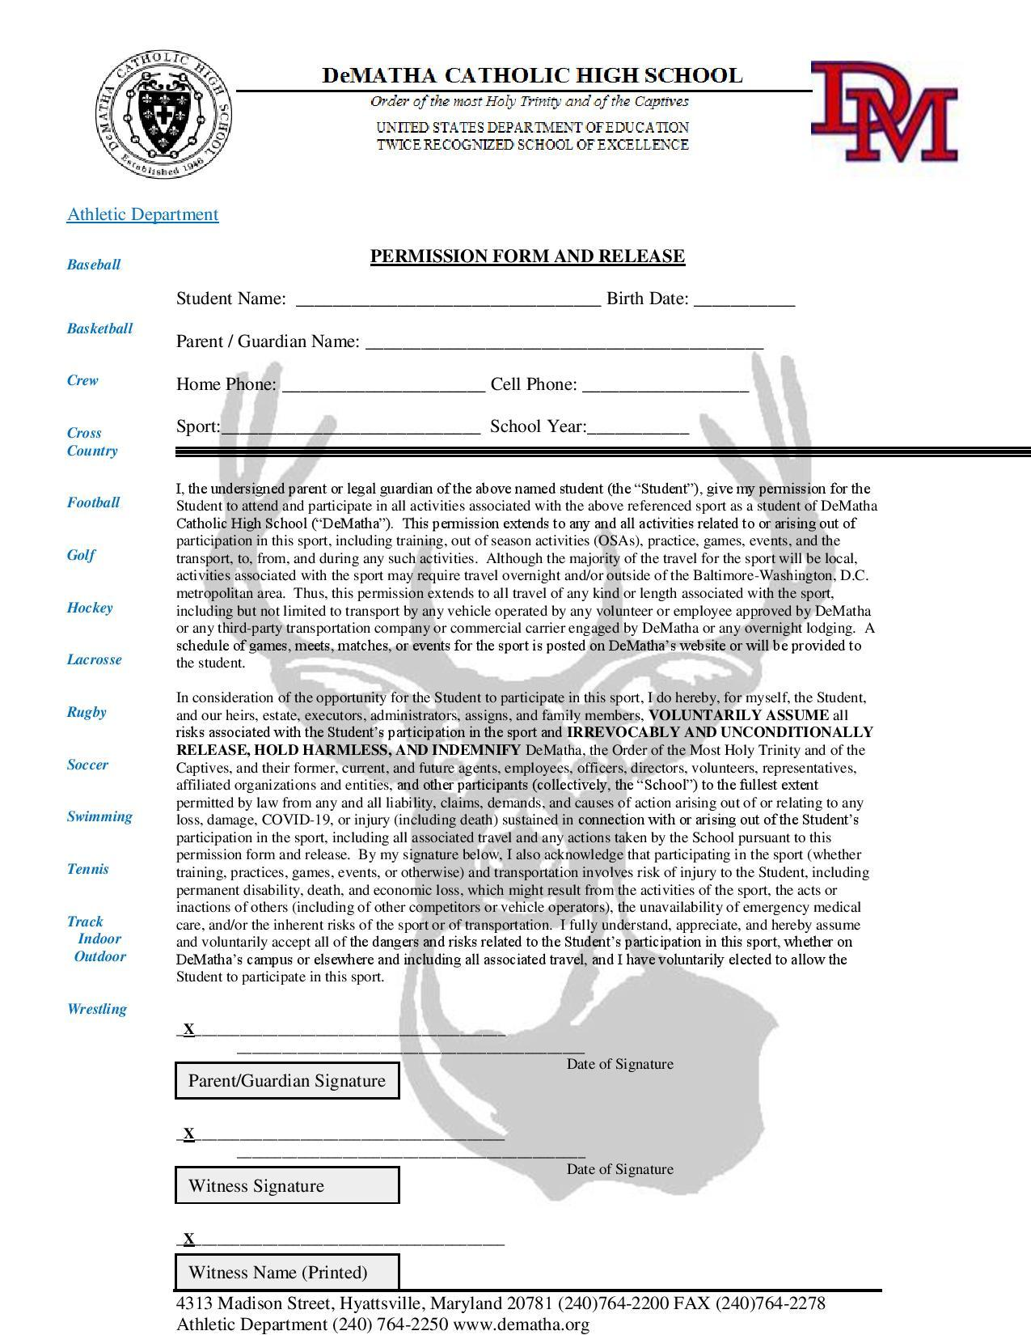
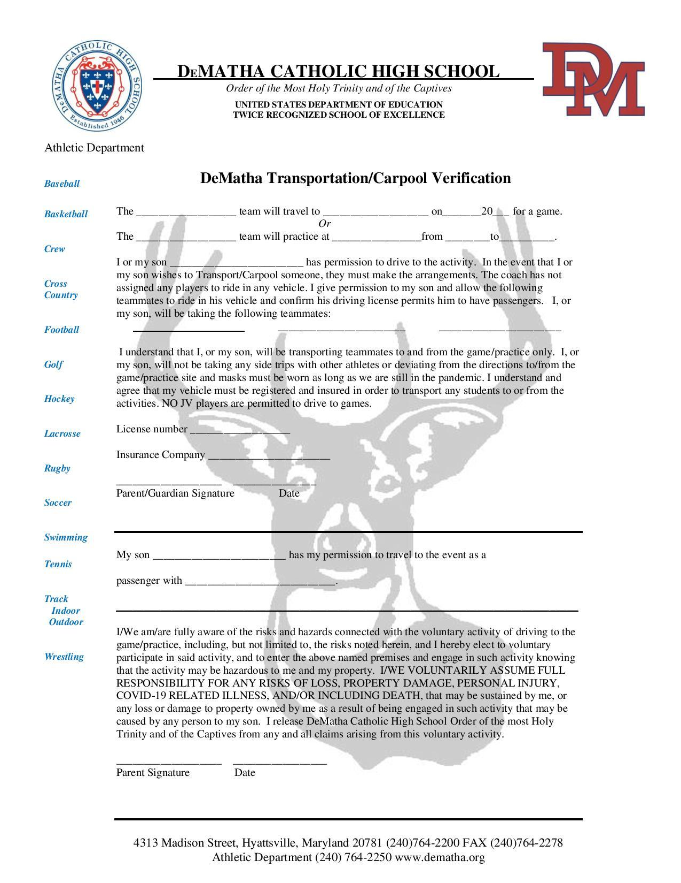

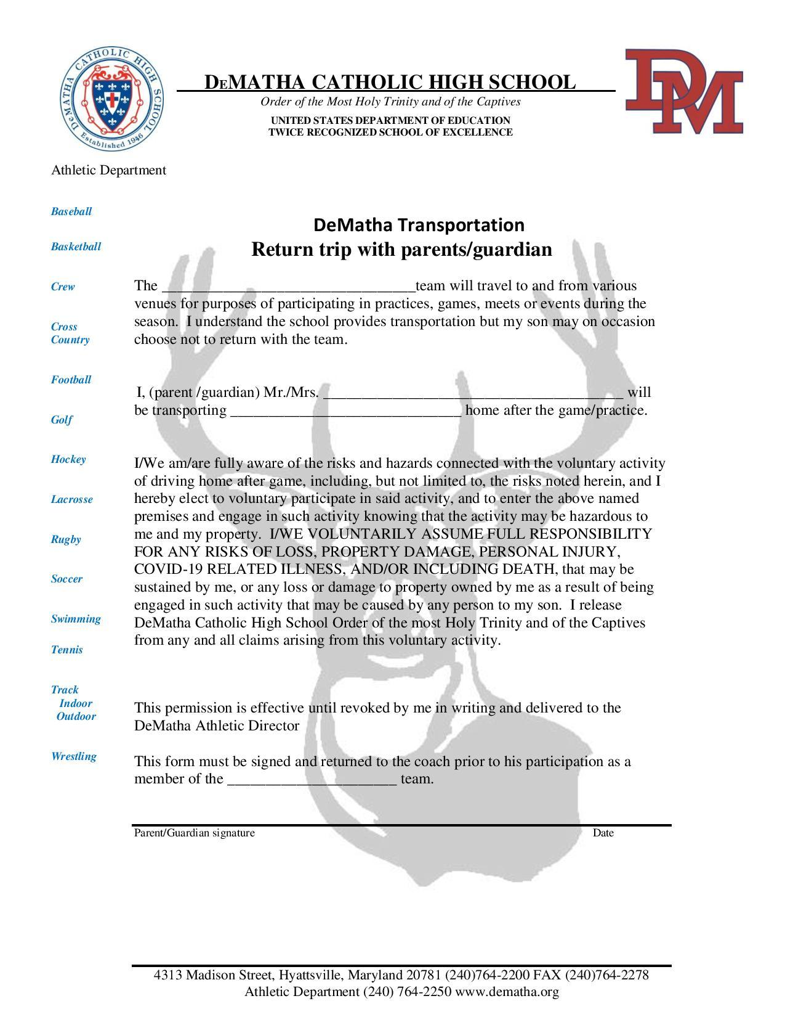

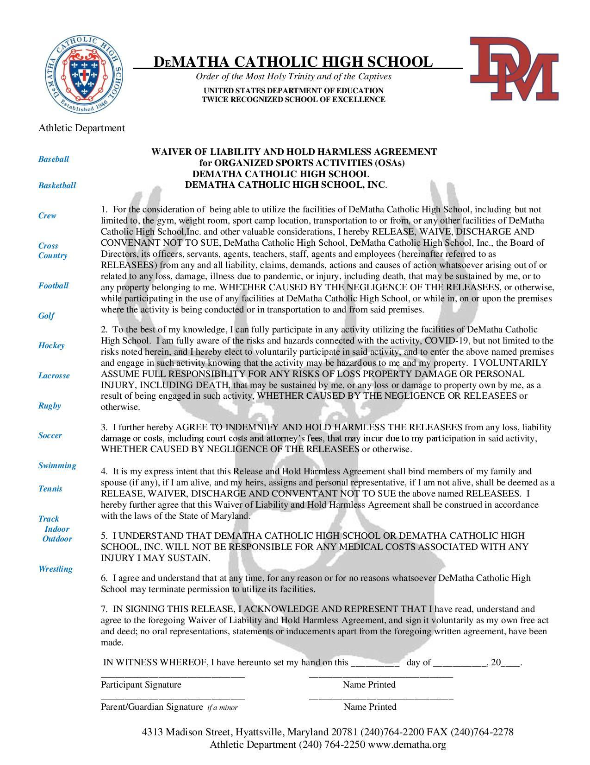

WCAC Athletic Transfer Policy
(Adopted 5-1-2020)
1. The WCAC Athletic Transfer Policy applies only to student participation in varsity sports. There are no transfer restrictions for student participation in junior varsity sports.
2. A student may only participate in sports for 8 consecutive semesters upon entering the 9th grade.
3. Subject to paragraph 4 below pertaining to an 11th grade student, 9th, 10th, and 11th grade students are permitted a ONE-TIME intra-conference transfer. To be eligible to play any varsity sports at the new WCAC member school during the school year of the transfer, the student must be enrolled in the new school on or before September 15 of that school year. There are NO intra-conference transfers after September 15 of a given school year. If the enrollment occurs after September 15, the student is ineligible to play any varsity sports at the new school for the remainder of that school year. Any intra-conference transfer in addition to the ONE-TIME intra-conference transfer renders the student ineligible to play any varsity sports at the new school for 365 days from the date of enrollment at the new school.
4. A 12th grade student is not permitted an intra-conference transfer. If a 12th grade student transfers from one WCAC member school to a new WCAC member school, he/she is ineligible to play any varsity sports. If during his/her 11th grade year a student plays a varsity sport or plays multiple varsity sports at one WCAC member school and thereafter uses the ONE-TIME intra-conference transfer, the student is ineligible to play that same sport or those same sports at the new school for 365 days from the date of enrollment at the new school. For the purpose of all provisions of this policy, a student is considered a 12th grade student the day after the end of his/her 11th grade school year.
5. Transfers from non-WCAC member schools:
a. Each 9th, 10th, and 11th grade student transferring from a non-WCAC member school to a WCAC member school is eligible to participate in all varsity sports immediately, provided the student has not previously used his/her ONE-TIME intra-conference transfer. If the student previously used his/her ONE-TIME intra-conference transfer, the student is ineligible to play varsity sports at the new school for 365 days from the date of enrollment at the new school.
b. A 12th grade student transferring from a non-WCAC member school to a WCAC member school is eligible to participate in all varsity sports provided he/she has enrolled in the WCAC member school by September 15 of that school year and provided the student has not previously used his/her ONE-TIME intra-conference transfer. If the enrollment occurs after September 15 or the student previously used his/her ONE-TIME intra-conference transfer, the student is ineligible to play any varsity sports at the new school.
6. Definitions: for the purpose of this Athletic Transfer Policy, the following definitions apply:
a. “Enrolled” and “Enrollment” in a school means a student has: i. Completed the application for the new school; ii. Has written acceptance from the new school; and iii. Payment of the Registration Fee has been received by the new school.
b. “Intra-conference transfer” means moving from one WCAC member school to another WCAC member school.
c. “ONE-TIME” is defined as a single intra-conference transfer for a 9th, 10th and 11th grade student during the student’s high school years.
d. “WCAC member school” means a school which is a part of The Washington Catholic Athletic Conference.
e. “Play” or “Played” means to appear or be listed on a varsity sport roster.
7. Each Head of School shall provide the WCAC Commissioner with legal guardianship documentation for a student upon request.
8. The WCAC and each member school shall publish the Athletic Transfer Policy, and all future amendment or modifications thereto, on their respective websites or on any other media intended to give notice to their students or those interested in becoming students at their school. It is the responsibility of each member school to provide a copy of the Athletic Transfer Policy to each student who intends to transfer or has transferred into their school.
9. The Athletic Transfer Policy is effective May 1, 2020 and shall remain as stated above until otherwise amended, modified, or terminated by the member schools.
10. All enrollment/transfer dates set forth by the WCAC must be adhered to:
Fall & Winter Sports - September 15,
Spring Sports - January 31

